**LAB4 TASK**

**K20-1052**

**1**

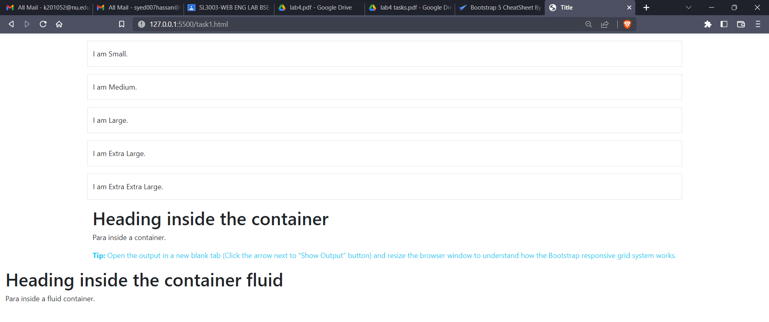

<body>

  <header>

    <!-- place navbar here -->

  </header>

  <main>

    <!-- Display all types of Container with border and display content inside what you observed when you

enlarge the in web browser. -->

    <div class="container-sm border py-3 my-3">I am Small.</div>

    <div class="container-md border py-3 my-3">I am Medium.</div>

    <div class="container-lg border py-3 my-3">I am Large.</div>

    <div class="container-xl border py-3 my-3">I am Extra Large.</div>

    <div class="container-xxl border py-3 my-3">I am Extra Extra Large.</div>

    <div class="container">

      <h1>Heading inside the container</h1>

      <p>Para inside a container.</p>

      <p class="mt-3 text-info"><strong>Tip:</strong> Open the output in a new blank tab (Click the

        arrow next to "Show Output" button) and resize the browser window to understand how the Bootstrap

        responsive grid system works.</p>

    </div>

    <div class="container-fluid">

      <h1>Heading inside the container fluid</h1>

      <p>Para inside a fluid container.</p>

    </div>

  </main>

  <footer>

    <!-- place footer here -->

  </footer>

  <!-- Bootstrap JavaScript Libraries -->

  <script src="https://cdn.jsdelivr.net/npm/@popperjs/core@2.11.6/dist/umd/popper.min.js"

    integrity="sha384-oBqDVmMz9ATKxIep9tiCxS/Z9fNfEXiDAYTujMAeBAsjFuCZSmKbSSUnQlmh/jp3" crossorigin="anonymous">

  </script>

  <script src="https://cdn.jsdelivr.net/npm/bootstrap@5.2.1/dist/js/bootstrap.min.js"

    integrity="sha384-7VPbUDkoPSGFnVtYi0QogXtr74QeVeeIs99Qfg5YCF+TidwNdjvaKZX19NZ/e6oz" crossorigin="anonymous">

  </script>

</body>

**2**

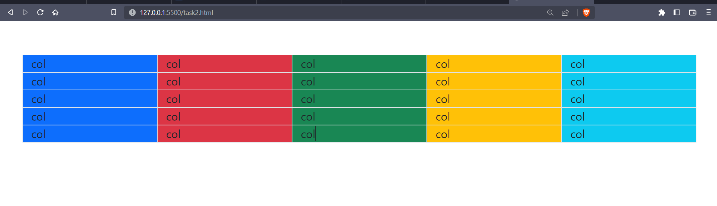

<body class="container pt-5">

    <div class="row ">

        <div class="col border bg-primary">col</div>

        <div class="col border bg-danger">col</div>

        <div class="col border bg-success">col</div>

        <div class="col border bg-warning">col</div>

        <div class="col border bg-info">col</div>

        <div class="w-100"></div>

        <div class="col border bg-primary">col</div>

        <div class="col border bg-danger">col</div>

        <div class="col border bg-success">col</div>

        <div class="col border bg-warning">col</div>

        <div class="col border bg-info">col</div>

        <div class="w-100"></div>

        <div class="col border bg-primary">col</div>

        <div class="col border bg-danger">col</div>

        <div class="col border bg-success">col</div>

        <div class="col border bg-warning">col</div>

        <div class="col border bg-info">col</div>

        <div class="w-100"></div>

        <div class="col border bg-primary">col</div>

        <div class="col border bg-danger">col</div>

        <div class="col border bg-success">col</div>

        <div class="col border bg-warning">col</div>

        <div class="col border bg-info">col</div>

        <div class="w-100"></div>

        <div class="col border bg-primary">col</div>

        <div class="col border bg-danger">col</div>

        <div class="col border bg-success">col</div>

        <div class="col border bg-warning">col</div>

        <div class="col border bg-info">col</div>

      </div>

</body>

**3**

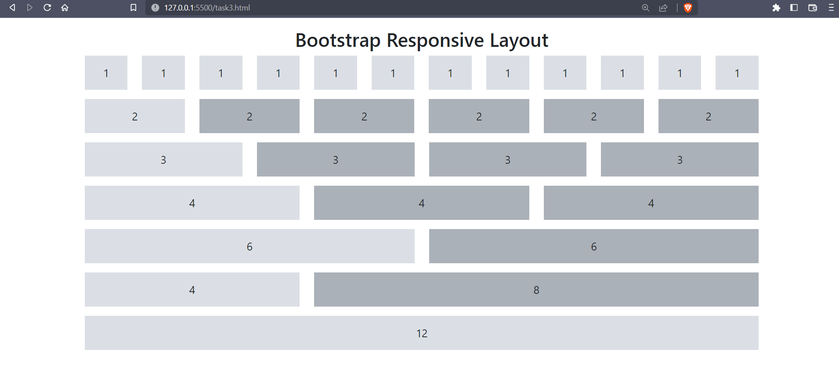

<body>

    <h2 class="text-center mt-3">Bootstrap Responsive Layout</h2>

    <div class="container">

      <!--Row with two equal columns-->

      <div class="row">

        <div class="col-md-1">

          <div class="demo-content">1</div>

        </div>

        <div class="col-md-1">

          <div class="demo-content">1</div>

        </div>

        <div class="col-md-1">

          <div class="demo-content">1</div>

        </div>

        <div class="col-md-1">

          <div class="demo-content">1</div>

        </div>

        <div class="col-md-1">

          <div class="demo-content">1</div>

        </div>

        <div class="col-md-1">

          <div class="demo-content">1</div>

        </div>

        <div class="col-md-1">

          <div class="demo-content">1</div>

        </div>

        <div class="col-md-1">

          <div class="demo-content">1</div>

        </div>

        <div class="col-md-1">

          <div class="demo-content">1</div>

        </div>

        <div class="col-md-1">

          <div class="demo-content">1</div>

        </div>

        <div class="col-md-1">

          <div class="demo-content">1</div>

        </div>

        <div class="col-md-1">

          <div class="demo-content">1</div>

        </div>

      </div>

      <!--Row with two columns divided in 1:2 ratio-->

      <div class="row">

        <div class="col-md-2">

          <div class="demo-content">2</div>

        </div>

        <div class="col-md-2">

          <div class="demo-content bg-alt">2</div>

        </div>

        <div class="col-md-2">

          <div class="demo-content bg-alt">2</div>

        </div>

        <div class="col-md-2">

          <div class="demo-content bg-alt">2</div>

        </div>

        <div class="col-md-2">

          <div class="demo-content bg-alt">2</div>

        </div>

        <div class="col-md-2">

          <div class="demo-content bg-alt">2</div>

        </div>

      </div>

      <!--Row with two columns divided in 1:3 ratio-->

      <div class="row">

        <div class="col-md-3">

          <div class="demo-content">3</div>

        </div>

        <div class="col-md-3">

          <div class="demo-content bg-alt">3</div>

        </div>

        <div class="col-md-3">

          <div class="demo-content bg-alt">3</div>

        </div>

        <div class="col-md-3">

          <div class="demo-content bg-alt">3</div>

        </div>

      </div>

      <div class="row">

        <div class="col-md-4">

          <div class="demo-content">4</div>

        </div>

        <div class="col-md-4">

          <div class="demo-content bg-alt">4</div>

        </div>

        <div class="col-md-4">

          <div class="demo-content bg-alt">4</div>

        </div>

      </div>

      <div class="row">

        <div class="col-md-6">

          <div class="demo-content">6</div>

        </div>

        <div class="col-md-6">

          <div class="demo-content bg-alt">6</div>

        </div>

      </div>

      <div class="row">

        <div class="col-md-4">

          <div class="demo-content">4</div>

        </div>

        <div class="col-md-8">

          <div class="demo-content bg-alt">8</div>

        </div>

      </div>

      <div class="row">

        <div class="col-md-12">

          <div class="demo-content">12</div>

        </div>

      </div>

    </div>

  </body>

**4**

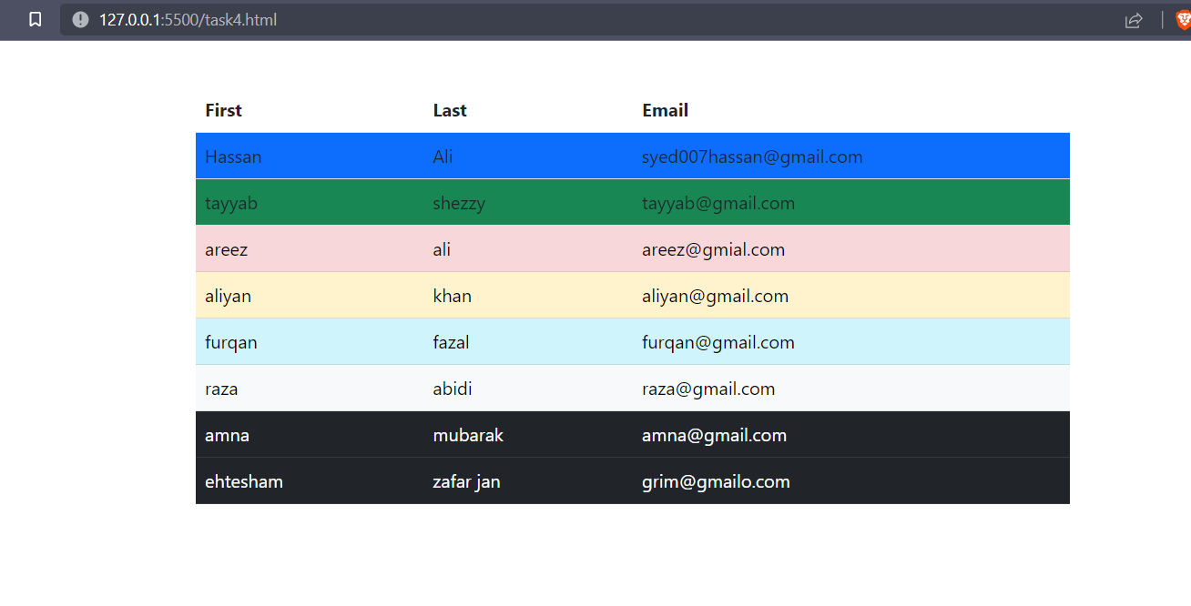

 <body>

    <table class="container table w-50" style="margin-top: 40px">

      <thead>

        <tr class="table">

          <th scope="col">First</th>

          <th scope="col">Last</th>

          <th scope="col">Email</th>

        </tr>

      </thead>

      <tbody>

        <tr class="table bg-primary">

          <td>Hassan</td>

          <td>Ali</td>

          <td class="w-50">syed007hassan@gmail.com</td>

        </tr>

        <tr class="table bg-success">

          <td>tayyab</td>

          <td>shezzy</td>

          <td>tayyab@gmail.com</td>

        </tr>

        <tr class="table-danger">

          <td>areez</td>

          <td>ali</td>

          <td>areez@gmial.com</td>

        </tr>

        <tr class="table-warning">

          <td>aliyan</td>

          <td>khan</td>

          <td>aliyan@gmail.com</td>

        </tr>

        <tr class="table-info">

          <td>furqan</td>

          <td>fazal</td>

          <td>furqan@gmail.com</td>

        </tr>

        <tr class="table-light">

          <td>raza</td>

          <td>abidi</td>

          <td>raza@gmail.com</td>

        </tr>

        <tr class="table-dark">

          <td>amna</td>

          <td>mubarak</td>

          <td>amna@gmail.com</td>

        </tr>

        <tr class="table-dark">

          <td>ehtesham</td>

          <td>zafar jan</td>

          <td>grim@gmailo.com</td>

        </tr>

      </tbody>

    </table>

  </body>

**5-**

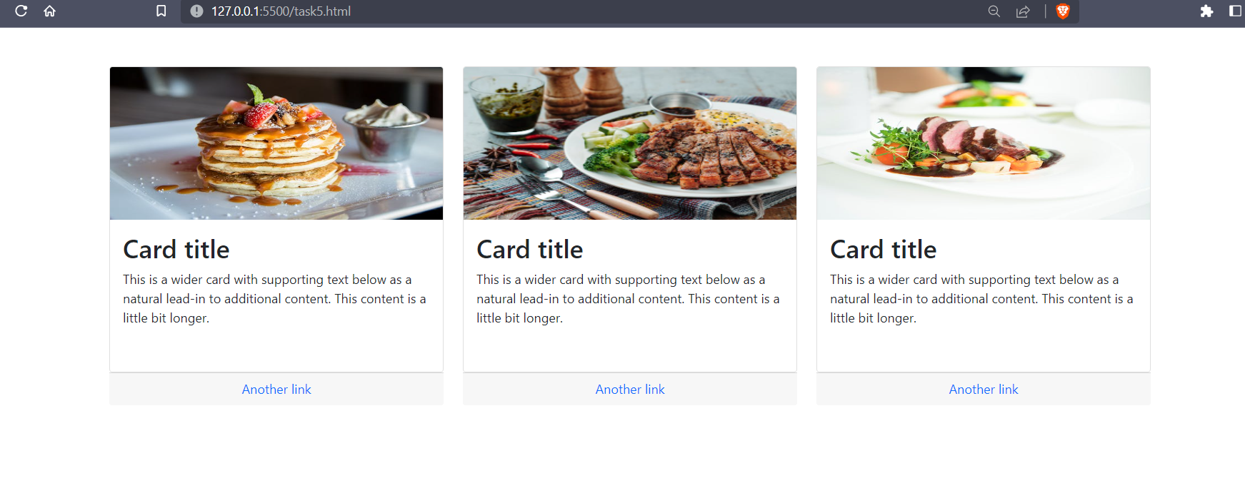

<body>

    <div class="container mt-5">

      <div class="row">

        <div class="col-md-4 col-sm-1 col-lg-4">

          <div class="card h-75">

            <img

              src="https://images.pexels.com/photos/376464/pexels-photo-376464.jpeg?auto=compress&cs=tinysrgb&w=600"

              class="card-img-top h-50"

              alt="card-img-top"

            />

            <div class="card-body">

              <h2 class="card-title">Card title</h2>

              <p class="card-text">

                This is a wider card with supporting text below as a natural

                lead-in to additional content. This content is a little bit

                longer.

              </p>

            </div>

          </div>

          <div class="card-footer text-muted text-center">

            <a href="#" class="card-link text-decoration-none">Another link</a>

          </div>

        </div>

        <div class="col-md-4">

          <div class="card h-75">

            <img

              src="https://images.pexels.com/photos/3186654/pexels-photo-3186654.jpeg?auto=compress&cs=tinysrgb&w=600"

              class="card-img-top h-50"

              alt="card-img-top"

            />

            <div class="card-body">

              <h2 class="card-title">Card title</h2>

              <p class="card-text">

                This is a wider card with supporting text below as a natural

                lead-in to additional content. This content is a little bit

                longer.

              </p>

            </div>

          </div>

          <div class="card-footer text-muted text-center">

            <a href="#" class="card-link text-decoration-none">Another link</a>

          </div>

        </div>

        <div class="col-md-4">

          <div class="card h-75">

            <img

              src="https://images.pexels.com/photos/299347/pexels-photo-299347.jpeg?auto=compress&cs=tinysrgb&w=600"

              class="card-img-top h-50"

              alt="card-img-top"

            />

            <div class="card-body">

              <h2 class="card-title">Card title</h2>

              <p class="card-text">

                This is a wider card with supporting text below as a natural

                lead-in to additional content. This content is a little bit

                longer.

              </p>

            </div>

          </div>

          <div class="card-footer text-muted text-center">

            <a href="#" class="card-link text-decoration-none">Another link</a>

          </div>

        </div>

      </div>

    </div>

  </body>

**6**

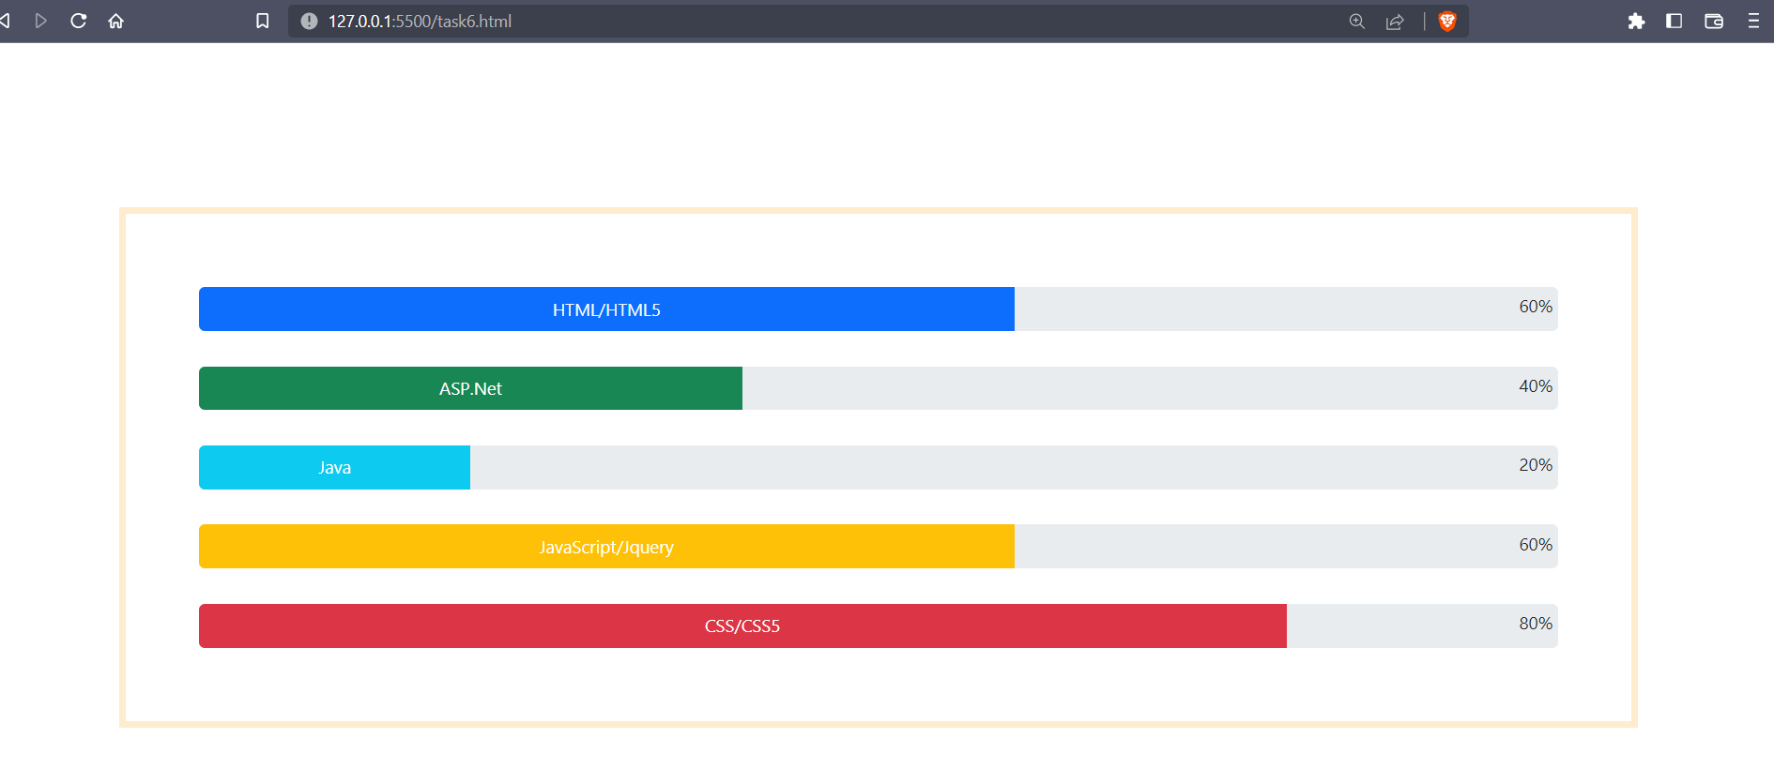

 <body class="container">

    <br />

    <br /><br />

    <div class="progress_bar">

      <div class="progress" style="height: 30px">

        <div

          class="progress-bar bg-primary text-light text-body-emphasis progress-bar-animated"

          role="progressbar"

          style="width: 60%"

          aria-valuenow="25"

          aria-valuemin="0"

          aria-valuemax="100"

        >

          HTML/HTML5

        </div>

        <p class="mt-1 ms-auto me-1">60%</p>

      </div>

      <br />

      <div class="progress" style="height: 30px">

        <div

          class="progress-bar bg-success"

          role="progressbar"

          style="width: 40%"

          aria-valuenow="50"

          aria-valuemin="0"

          aria-valuemax="100"

        >

          ASP.Net

        </div>

        <p class="mt-1 ms-auto me-1">40%</p>

      </div>

      <br />

      <div class="progress" style="height: 30px">

        <div

          class="progress-bar bg-info"

          role="progressbar"

          style="width: 20%"

          aria-valuenow="75"

          aria-valuemin="0"

          aria-valuemax="100"

        >

          Java

        </div>

        <p class="mt-1 ms-auto me-1">20%</p>

      </div>

      <br />

      <div class="progress" style="height: 30px">

        <div

          class="progress-bar bg-warning"

          role="progressbar"

          style="width: 60%"

          aria-valuenow="100"

          aria-valuemin="0"

          aria-valuemax="100"

        >

          JavaScript/Jquery

        </div>

        <p class="mt-1 ms-auto me-1">60%</p>

      </div>

      <br />

      <div class="progress" style="height: 30px">

        <div

          class="progress-bar bg-danger"

          role="progressbar"

          style="width: 80%"

          aria-valuenow="100"

          aria-valuemin="0"

          aria-valuemax="100"

        >

          CSS/CSS5

        </div>

        <p class="mt-1 ms-auto me-1">80%</p>

      </div>

    </div>

  </body>

**7**

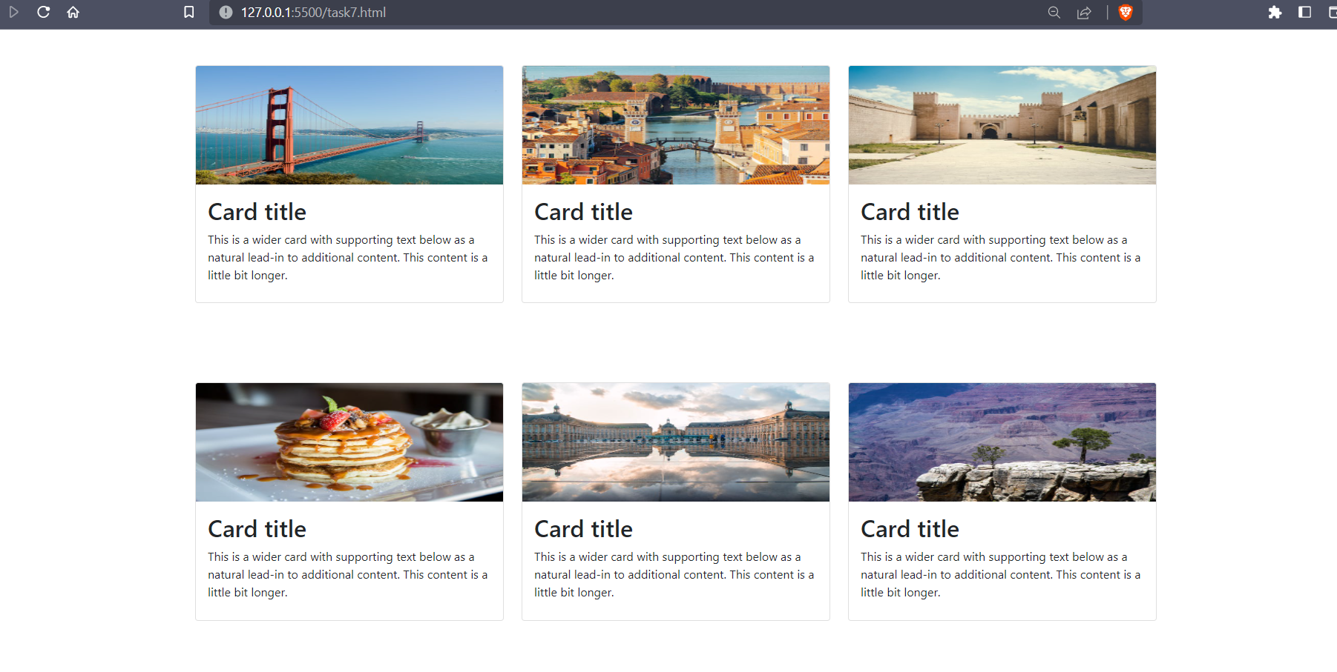

 <body>

    <div class="container mt-5">

      <div class="row mb-0">

        <div class="col-md-4 col-sm-1 col-lg-4 m-0">

          <div class="card h-75">

            <img

              src="https://images.pexels.com/photos/208745/pexels-photo-208745.jpeg?auto=compress&cs=tinysrgb&w=600"

              class="card-img-top h-50"

              alt="card-img-top"

            />

            <div class="card-body">

              <h2 class="card-title">Card title</h2>

              <p class="card-text">

                This is a wider card with supporting text below as a natural

                lead-in to additional content. This content is a little bit

                longer.

              </p>

            </div>

          </div>

        </div>

        <div class="col-md-4 m-0">

          <div class="card h-75">

            <img

              src="https://images.pexels.com/photos/1462935/pexels-photo-1462935.jpeg?auto=compress&cs=tinysrgb&w=600"

              class="card-img-top h-50"

              alt="card-img-top"

            />

            <div class="card-body">

              <h2 class="card-title">Card title</h2>

              <p class="card-text">

                This is a wider card with supporting text below as a natural

                lead-in to additional content. This content is a little bit

                longer.

              </p>

            </div>

          </div>

        </div>

        <div class="col-md-4 m-0">

          <div class="card h-75">

            <img

              src="https://images.pexels.com/photos/947185/pexels-photo-947185.jpeg?auto=compress&cs=tinysrgb&w=600"

              class="card-img-top h-50"

              alt="card-img-top"

            />

            <div class="card-body">

              <h2 class="card-title">Card title</h2>

              <p class="card-text">

                This is a wider card with supporting text below as a natural

                lead-in to additional content. This content is a little bit

                longer.

              </p>

            </div>

          </div>

        </div>

      </div>

      <div class="row mt-0 pt-0">

        <div class="col-md-4 col-sm-1 col-lg-4 mt-0">

          <div class="card h-75">

            <img

              src="https://images.pexels.com/photos/376464/pexels-photo-376464.jpeg?auto=compress&cs=tinysrgb&w=600"

              class="card-img-top h-50"

              alt="card-img-top"

            />

            <div class="card-body">

              <h2 class="card-title">Card title</h2>

              <p class="card-text">

                This is a wider card with supporting text below as a natural

                lead-in to additional content. This content is a little bit

                longer.

              </p>

            </div>

          </div>

        </div>

        <div class="col-md-4 mt-0">

          <div class="card h-75">

            <img

              src="https://images.pexels.com/photos/1059078/pexels-photo-1059078.jpeg?auto=compress&cs=tinysrgb&w=600"

              class="card-img-top h-50"

              alt="card-img-top"

            />

            <div class="card-body">

              <h2 class="card-title">Card title</h2>

              <p class="card-text">

                This is a wider card with supporting text below as a natural

                lead-in to additional content. This content is a little bit

                longer.

              </p>

            </div>

          </div>

        </div>

        <div class="col-md-4 mt-0">

          <div class="card h-75">

            <img

              src="https://images.pexels.com/photos/257352/pexels-photo-257352.jpeg?auto=compress&cs=tinysrgb&w=600"

              class="card-img-top h-50"

              alt="card-img-top"

            />

            <div class="card-body">

              <h2 class="card-title">Card title</h2>

              <p class="card-text">

                This is a wider card with supporting text below as a natural

                lead-in to additional content. This content is a little bit

                longer.

              </p>

            </div>

          </div>

        </div>

      </div>

    </div>

  </body>